2023-2024 Calendar

Troop 13 Events
Sep 8-10 - Bridgeport State Recreation Area Canoe Derby
Sep - Marathon Clean-up
Oct 20-22 – Campout?
Nov 10-12 – Campout?
Nov 13 – Court of Honor
Feb 19 – Court of Honor
May 13 – Court of Honor
TBD - Summer Camp
TBD - Troop 13 Centennial Celebration

Patrol Leaders’ Council Meetings at 6:00
TBD

Troop Committee Meetings on Tuesdays at 7:00
Sep 5, Oct 3, Nov 7,
Dec 5, Jan 9, Feb 6,
Mar 5, Apr 2, May 7

Troop Meetings on Mondays at 7:00 except:
Sep 4, Sep 25, Dec 25, Jan 1,
Jan 8, Feb 19, Apr 1

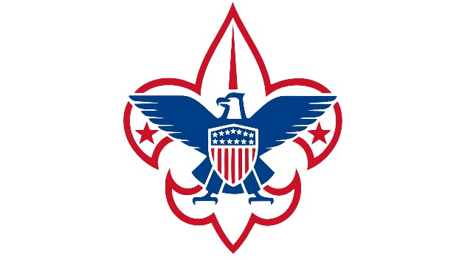
Troop 13
Court of Honor

August 14, 2023

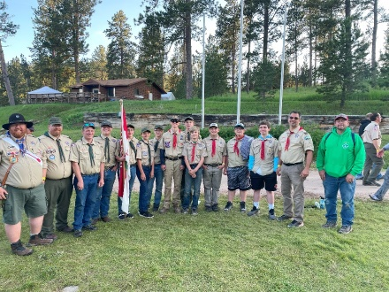  Medicine Mountain Scout Camp | 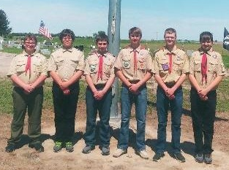  Memorial Day Flag Ceremony
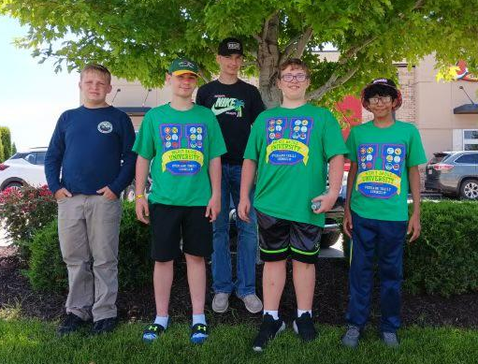  Merit Badge University | 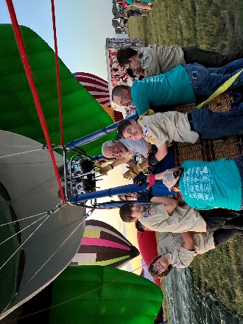  Old West Balloon Fest Crew

2023 Totals to Date
Total Rank Advancements – 9
Total Merit Badges – 55
Total Special Awards – 6
Total Nights Camping – 47
Total Scout Service Hours – 159
Opening Flag Ceremony

Welcome

Presentation of Rank Advancement
Scout: Ryan Montgomery
Skylar Montgomery
Second Class: Andrew Peck
Davin Powell
Drake Connell
First Class: Andrew Peck
Davin Powell

Presentation of Awards
Firem'n Chit: Andrew Peck
Davin Powell
Totin' Chip: Andrew Peck
Davin Powell
Drake Connell
William Schnell

Presentation of Merit Badges
Archery: Andrew Peck
Colton Charbonneau
Davin Powell
Art: Davin Powell
Astronomy: Andrew Peck
Basketry: Davin Powell
Canoeing: Colton Charbonneau
Chemistry: Andrew Peck
Davin Powell
William Schnell
Citizenship in Society: Colton Charbonneau
Citizenship in the World: Collin Phillips
Crime Prevention: Drake Connell
Dog Care: Andrew Peck
Electricity: Andrew Peck
Davin Powell
Engineering: Andrew Peck
Davin Powell
William Schnell
Fishing: Andrew Peck
Forestry: Andrew Peck
Davin Powell
Drake Connell
William Schnell
Game Design: Davin Powell
Drake Connell
Geology: Colton Charbonneau
Golf: Andrew Peck
Leatherwork: Drake Connell
Photography: Davin Powell
Railroading: Andrew Peck
Davin Powell
Drake Connell
Rifle Shooting: Andrew Peck
Drake Connell
Scholarship: Davin Powell
Scout Heritage: Andrew Peck
Davin Powell
Drake Connell
Search and Rescue: Colton Charbonneau
Small-Boat Sailing: Colton Charbonneau
Surveying: William Schnell
Swimming: Colton Charbonneau
Truck Transportation: Drake Connell
Veterinarian Medicine: William Schnell
Welding: Andrew Peck
Drake Connell
Wood Carving: Drake Connell

Closing Flag Ceremony

Merit Badge Counselors Needed

